**AITCHISON COLLEGE**

**LAHORE**



**A GUIDE TO ADMISSIONS**

**(SYLLABUSES)**

**ACADEMIC YEAR 2019-2020**

**C O N T E N T S**

|  |  |
| --- | --- |
|  | **Page** |
| **Junior School**   1. Syllabus for Grade 1 (K-1) | 2 |
| 1. Syllabus for Grade 2 (K-2) | 5 |
| 1. Syllabus for Grade 3 (K-3) | 8 |
| 1. Syllabus for Grade 4 (K-4) | 11 |
| 1. Syllabus for Grade 5 (K-5) | 15 |
| 1. Syllabus for Grade 6 (K-6) | 19 |
| **Preparatory School** | |
| 1. Syllabus for Grade 7 (E-2) | 23 |
| 1. Syllabus for Grade 8 (M-1) | 26 |
| 1. Syllabus for Grade 9 (M-2) | 29 |
| **Senior School** | |
| 1. Syllabus for Grade 10 (C1) | 30 |
| 1. Syllabus for Grade 11 (C2) | 31 |
| The Guide to Syllabuses is a ‘guide only.’ Papers for admission are set according to what the College requires of each year group for the purpose of ranking only. There is no ‘pass’ or ‘fail.’  Please refer to FAQ as information to be read in conjunction with this booklet. | |

**JUNIOR SCHOOL**

FOR ADMISSION TO CLASS: Grade 1 or K-1 **(Guide only)**

**MATHEMATICS**

**Note:** Use of calculator is not allowed.

Questions will be based on some or all of the following topics:

|  |  |
| --- | --- |
| 1. Pre-number | Use comparative terms for assessment of size, length, thickness and height of an object; apply descriptors such as bigger-smaller, longer-shorter, thicker-thinner, higher-lower etc. and other related words in connection with the above mentioned measurable parameters of objects. |
| 2. Sets | Classify similar/dissimilar sets; demonstrate one-to-one matching notion of as many as, more or less etc. and recognise equivalent/non-equivalent sets. |
| 3. Whole number | Recognise numbers 1-50 inclusive through their association with objects and pictures (e.g. use of the idea of similar/dissimilar); count, name and write the numbers 1-50 inclusive; know which number comes before a given number, between two given numbers, follows a given number; order numbers 1-50 inclusive; knowledge of place value of a number (e.g. units and tens up to and including 50); addition by combining sets; addition of two numbers in which the sum does not exceed 48; subtraction of numbers represented by digits (e.g. manipulations with numbers 1-9 inclusive). |
| 4. Shapes | Identify similar/dissimilar shapes (e.g. illustrated with the use of a circle, rectangle, square, triangle and oval); show awareness that each of these shapes has a different pattern. |

**JUNIOR SCHOOL** *(continued)*

FOR ADMISSION TO CLASS: Grade 1 or K-1 **(Guide only)**

**ENGLISH**

**Note:** Questions will be based on some or all of the following areas in 1 & 2:

|  |  |
| --- | --- |
| 1. Words | Candidates will be expected to have developed: familiarity with phonics and spelling of simple words; knowledge of graphemes/phonemes correspondence through identifying and writing initial and final phonemes in words (e.g. fit, pan, mat etc.); recognition of sound and spelling patterns through use of rhyme to identify rhyming words (e.g. hop, top, mop and fat, mat, pat etc.). |
| 2. Sentences | Candidates’ understanding of basic rules for grammar and punctuation will be tested through: Use of a capital letter for the start of their own name and at the beginning of a sentence; construction of very simple sentences (e.g. 4-5 words); appreciation that a full stop ends a sentence; recognition of upper case and lower case letters of the alphabet and their sequence; phonological awareness (e.g. sounds of letters and words and be able to read them); knowledge sounds of vowels; formation and reading of three letter words, sight based vocabulary and ability to label pictures. |

**JUNIOR SCHOOL** *(continued)*

FOR ADMISSION TO CLASS: Grade 1 or K-1 **(Guide only)**

**SECTION B (URDU)**

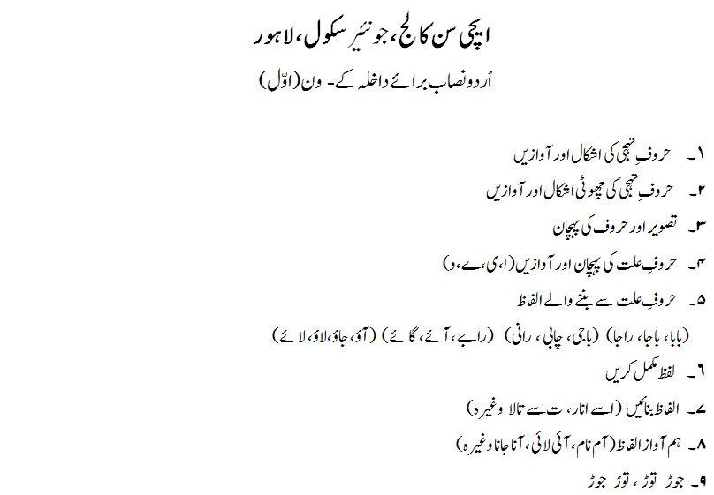

**JUNIOR SCHOOL** *(continued)*

FOR ADMISSION TO CLASS: Grade 2 or K-2 **(Guide only)**

**MATHEMATICS Time: 1 Hour**

**Note:** Use of calculator is not allowed.

Questions will be based on some or all of the following topics:

|  |  |
| --- | --- |
| 1. Pre-number | Use comparative terms for assessment of size, length, thickness, height, capacity, weight etc. (or any other suitable parameter) of an object; apply descriptors such as bigger-smaller, longer-shorter, thicker-thinner, higher-lower, more-less, heavier-lighter etc. and other related words in connection with the above mentioned measurable parameters of objects. |
| 2. Sets | Classify similar/dissimilar sets; demonstrate one-to-one matching notion of as many as, more or less etc.; recognise an empty set and understand its link to the number zero. |
| 3. Whole number | Recognise and name numbers (up to hundreds); order numbers (1-50 inclusive); arrange these numbers on a ray and use it to represent addition and subtraction; appreciate the place value of a number e.g. units, tens and hundreds; add and subtract numbers up to hundreds; multiply single digit numbers and use multiplication tables (e.g. for 2, 3, 4, 5, 6 and 7) to solve simple problems. |
| 4. Shapes | Identify common shapes (e.g. circle, rectangle, square, triangle and oval); distinguish between ‘open’ and ‘closed’ shapes. |
| 5. Fractions | Show familiarity with fractions and their symbolic notation (e.g. 1/2, 1/3, 2/3, 1/4, 2/4, 3/4 etc.). Identify fractions from highlighted sections of graphics of shapes; identify fractions on a given shape through suitable highlighting of the relevant portion. |
| 6. Time | Read and state time; name days and how many constitute a week; recall the names of the calendar months. |
| 7. Money | Identify currency and perform manipulation involving the denominations of currency in terms of coins and notes (e.g. Rs 1, Rs 2, Rs 5 and Rs 10, Rs 20, Rs 50, Rs 100); select correct amount of money to buy and sell items. |
| 8. Graphs | Interpret picture graphs. |
| 9. Patterns | Sort and classify objects by different properties; order objects by size or other numerical property; identify, analyse, and extend patterns of objects or numbers and recognise the same pattern in different manifestations. |

**JUNIOR SCHOOL** *(continued)*

FOR ADMISSION TO CLASS: Grade 2 or K-2 **(Guide only)**

**ENGLISH Time: 1 Hour**

**Note:** Questions will be based on some or all of the following areas in 1 & 2.

Read and comprehend a short story or passage or picture by answering questions that require: responses to, or descriptions of, events, actions or people; reasons for an event or action; use words or facts or information to answer questions; true or false responses.

1. Comprehension

Respond in writing to a question or topic or a picture. A candidate’s language/written skills will be gauged from an ability to form responses or convey ideas with coherency, use of vocabulary or choice of words, accuracy of spelling, simple sentence construction, imagination, description, and application of basic grammar rules.

Language skills may include: recognition of the alphabet, accurate use of nouns and verbs, sequence of words, identifying similar sounds, use of vowels, adjectives, rearranging narrative in correct sequence, constructing simple sentences from given words or instructions.

1. Language Skills & Writing

**JUNIOR SCHOOL** *(continued)*

FOR ADMISSION TO CLASS: Grade 2 or K-2 **(Guide only)**

**SECTION B (URDU) Time: 1 Hour**

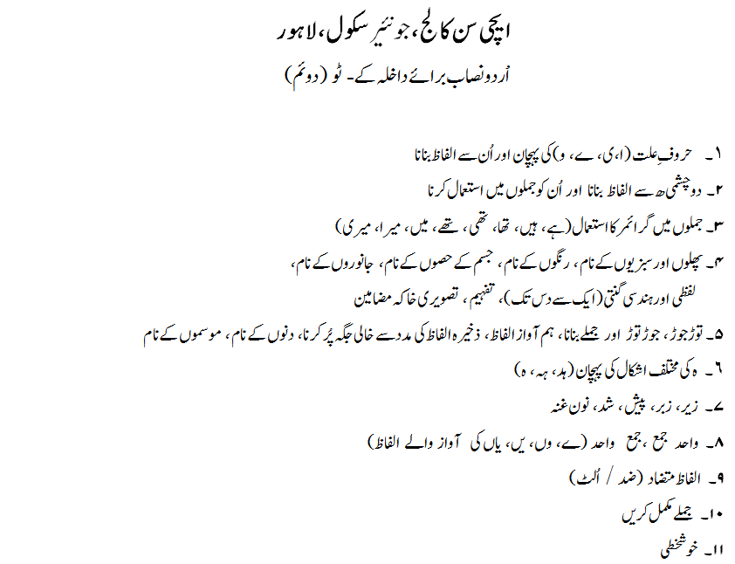

**JUNIOR SCHOOL** *(continued)*

FOR ADMISSION TO CLASS: Grade 3 or K-3 **(Guide only)**

**MATHEMATICS Time: 1 Hour**

**Note:** Use of calculator is not allowed.

Questions will be based on some or all of the following topics:

|  |  |
| --- | --- |
| 1. Pre-number | Read/write numbers up to and including 1000; name numbers up to 9999; knowledge of units, tens and hundreds; know place value of numbers up to and including 9999; arrange numbers (e.g. before, after and between a given number); ordinal numbers up to 10; use mathematical symbols (e.g. greater than, less than, equal to); arrange numbers in ascending/descending order for numbers up to and including 9999. |
| 2. Addition and Subtraction | These two mathematical techniques will be assessed through pupils being able to: add up to 9999; use addition tables up to 9+9=18; undertake vertical addition and subtraction up to 9999 (without and with exchange); subtract up to 9999; understand commutative property of addition and solve word problems involving addition and subtraction. |
| 3. Multiplication | Multiply single digit numbers and one single digit number and a second three digit number (e.g. product up to 9999); understand commutative property of multiplication; apply multiplication tables (e.g. for 2, 3, 4, 5, 6, 7, 8 and 9) to solve simple problems. |
| 4. Division | Understand the term being an equal sharing (or distribution) without remainder; carry out long division (divisors = 2, 3, 4, 5, 6,7,8,9 and dividend up to 999) with or without remainder; complete sequence of numbers; recall odd and even numbers up to 999. |
| 5. Shapes | Identify number of edges, corners and boundaries of regions in relation to common shapes (e.g. circle, rectangle, square and oval etc.); show familiarity with terms such as locus, curve, open and closed curves, straight locus and a line segment. |
| 6. Fractions | Handle proper fractions (with denominators up to and including the number 9); recognise graphically illustrated terms such as a half, a third, a quarter etc. |
| 7. Time | Read and state time (e.g. for the 24 hour clock); recall the length of a day and number of days in a week. |
| 8. Money | Identify currency and perform manipulation with denominations of currency in terms of coinage and notes; select correct amount of money (up to and including 999) to buy and sell items. |
| 9. Calendar | State number of days in different months; state the names of months. |
| 10. Patterns | Sort and classify objects by different properties; order objects by size or other numerical property; identify, analyse, and extend patterns of objects or numbers and recognise the same pattern in different manifestations. |

**JUNIOR SCHOOL** *(continued)*

FOR ADMISSION TO CLASS: Grade 3 or K-3 **(Guide only)**

**ENGLISH Time: 1 Hour**

**Note:** Questions will be based on some or all of the following areas in 1 & 2:

Read and comprehend a short story or passage (non-fiction of fiction) or picture by: answering questions that require responses to, or description of, events, actions or people; reasons for an event; use words or facts or information to answer questions; true or false responses; predicting story endings.

1. Comprehension

Write a creative or imaginative response to a topic or picture. A candidate’s language/written skills will be gauged from an ability to form responses or convey ideas with coherency, use of vocabulary or choice of words, accuracy of spelling, simple sentence construction, imagination, description, and application of basic grammar rules.

Language skills may include: identification and use of rhyming words; ordering jumbled words or sentences; establishing alphabetical order; providing a suitable caption for a picture; recognizing vowels and consonants; number of syllables in words; correct uses of nouns, verbs (present and past), adjectives, articles, prefixes, suffixes, conjunctions, singular and plural forms, basic punctuation, question mark and use of capital letters.

1. Language Skills & Writing

**JUNIOR SCHOOL** *(continued)*

FOR ADMISSION TO CLASS: Grade 3 or K-3 **(Guide only)**

**SECTION B (URDU) Time: 1 Hour**

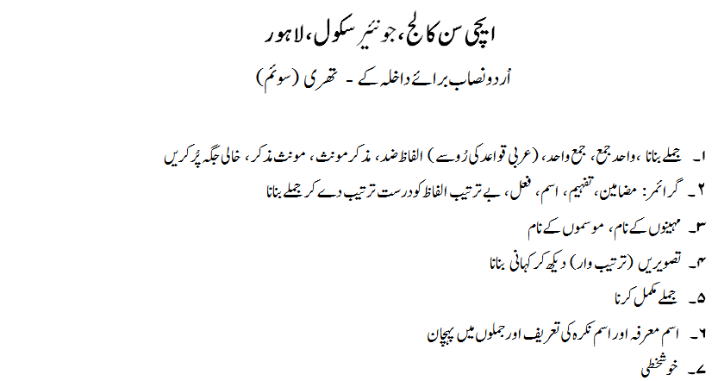

**JUNIOR SCHOOL** *(continued)*

FOR ADMISSION TO CLASS: Grade 4 or K-4 **(Guide only)**

**MATHEMATICS Time: 1 Hour**

**Note:** Use of calculator is not allowed.

Questions will be based on some or all of the following topics:

|  |  |
| --- | --- |
| 1. Decimal numeration system | Write number in words (up to 9999); recognise place value (up to 9999); arrange numbers in ascending and descending order; complete a given sequence of numbers; compare numbers; identify even and odd numbers (up to 9999). |
| 2. Addition | Add with and without exchange (up to 9999); solve word problems and handle addition tables. |
| 3. Subtraction | Subtract with and without exchange (up to 9999); solve word problems; deal with mixed addition and subtraction and handle subtraction tables. |
| 4. Multiplication | Apply tables 2-12, multiply two, three and four digits with the multiplier as a double digit; multiply a number by zero and 10, 20, …100; solve word problems involving one basic operation. |
| 5. Division | Divide numbers with and without remainder (dividend up to 9999 and divisor up to 12); relationship between division and multiplication; solve problems involving division. |
| 6. Common Fractions | Understand numerator and denominator; like and unlike fractions; proper, improper and mixed fractions; comparison, addition and subtraction of like fractions; derivation of rules for operations with fractions and their applications. |
| 7. Shapes and measures | Show familiarity with the idea of regions (e.g. circular, rectangular, triangular and square) and boundaries; demonstrate knowledge of common 2-D shapes (open and closed) and congruency of regions; know basic concepts of geometry (e.g. ray, line and segment); understand bilateral symmetry, linear measurement, congruency of segments and edges; recognise 3-D shapes (e.g. sphere, cylinder, cone, cuboid pyramid, triangular prism and cube) with regard to their faces, edges and corners; consider flat and non-flat surfaces; types of angles. |
| 8. Standard International (S.I.) Units | Recall S.I. units of length (km, m and cm only) and weight/mass (kg, g and mg only). |
| 9. Money | Identify currency and perform manipulation with denominations of currency in terms of coinage and notes; select correct amount of money (up to and including 9999) to buy and sell items. |
| 10. Calendar | Show a way to find out which year is a leap year. |
| 11. Graphs | Interpret picture graphs. |
| 12. Time | Read & identify 12 hour & 24 hour clocks. |
| 13. Patterns | Sort and classify objects by different properties; order objects by size or other numerical property; identify, analyse, and extend patterns of objects or numbers and recognise the same pattern in different manifestations. |

**JUNIOR SCHOOL** *(continued)*

FOR ADMISSION TO CLASS: Grade 4 or K-4 **(Guide only)**

**ENGLISH Time: 1 Hour**

**Note:** Questions will be based on some or all of the following in areas 1 & 2:

Analyse or make inferences from a short story or passage (non-fiction of fiction) or picture by: answering questions that require responses to, or description of, events, actions or people; reasons for an event; use words or facts or information to answer questions; true or false responses; predicting story endings. Demonstrate perception skills.

1. Comprehension

Write a creative or imaginative response to a topic or picture. This may also include imagining the beginning or end to a story. A candidate’s language/written skills will be gauged from an ability to form responses or convey ideas with coherency, imagination, powers of description, use of vocabulary or choice of words, accuracy of spelling, simple sentence construction, imagination, description, and application of basic grammar rules.

Language skills may include: using a variety of sentence types; correct use of nouns, verbs, adjectives, adverbs, confusing words, homophones, prepositions, conjunctions, articles, singular and plural, compound words, prefixes and suffixes, antonyms and homonyms, comparative and superlative adjectives, collective nouns, tenses, apostrophe and punctuation marks.

1. Language Skills & Writing

**JUNIOR SCHOOL** *(continued)*

FOR ADMISSION TO CLASS: Grade 4 or K-4 **(Guide only)**

**SECTION B (URDU) Time: 1 Hour**

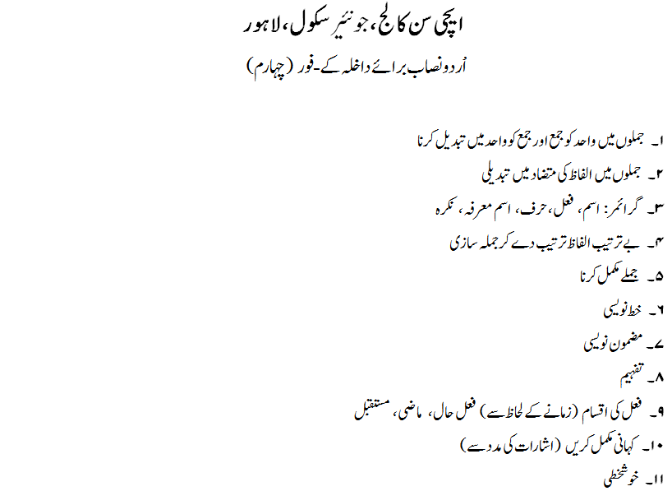

**JUNIOR SCHOOL** *(continued)*

FOR ADMISSION TO CLASS: Grade 5 or K-5 **(Guide only)**

**MATHEMATICS Time: 1 Hour**

**Note:** Use of calculator is not allowed.

Questions will be based on some or all of the following topics:

|  |  |
| --- | --- |
| 1. Decimal numeration system | Find place value of digits in numbers up to 7 digits; write and read numbers in words and/or figures containing 5-7 digits; order numbers up to one million (ascending and descending). |
| 2. Mathematical operations | Add whole numbers up to 7 digits; solve words problems on addition; subtract whole numbers up to 7 digits; solve word problems on subtraction; multiply whole numbers (multiplier 2 digit number/multiplicand 5 digit number); solve word problems on multiplication; understand distributive property of multiplication; divide whole numbers (divisor 2 digit number/dividend up to 999999); solve word problems on division. |
| 3. Shapes and measures | recognise tetrahedral and square pyramidal shapes and know about their faces, edges, corners, base and apex; deduce the regions, boundaries and interiors of 2-D shapes such as a triangle and quadrilateral; understand, define and measure angles; classify angles (e.g. acute, obtuse, right, straight and reflex); identify congruent angles; work with triangles; deduce the third angle of a triangle when two angles are given; know the characteristics of a quadrilateral. |
| 4. Fractions | Reduce common fractions to simplest form; manipulate equivalent fractions; convert common fractions (e.g. mixed to improper and vice versa). |
| 5. Operations on common fractions | Add and subtract two like common fractions, two like common fractions that are classified as mixed, two unlike common fractions, two mixed unlike common fractions; multiply two and three common fractions; divide common fractions; solve word problems on addition and subtraction of common fractions; manipulate decimal fractions; understand tenths, hundredths, thousandths; read numbers involving decimal points; understand place value of digits to the right of the decimal point up to 1000ths; add and subtract decimal fractions. |
| 6. Compound quantities | Carry out conversion, addition and subtraction – all these illustrated with currency; use length and undertake conversion, addition and subtraction (in m and cm only). |
| 7. Area and perimeter | Calculate the perimeter of triangular regions (in m and cm only); solve word problems on perimeter; understand the term area and know its units; find the area of rectangular and square regions of space (with non-standard and standard units e.g. m2, km2, cm2); apply the formula for calculation of the area of rectangular and square regions of space (units: m2, km2, cm2); undertake word problems on area. |
| 8. Volume | Understand volume; find volumes of cube and cuboid; know the units of volume (e.g. m3); use the formula for calculation of volume of cube and cuboid; solve word problems on volume. |
| 9. Graphs | Interpret graphs (e.g. dot graph, line graph and bar graph). |
| 10. Time | Read and identify 12 hour & 24 hour clocks. |
| 11. Money | Identify currency and perform manipulation with denominations of currency in terms of coinage and notes; select correct amount of money (up to and including 9999) to buy and sell items. |
| 12. Sets | Concepts of a set and its members; finite and infinite sets; singleton and empty sets; cardinality of a set; subsets |
| 13. Percentage | Percentage of whole numbers; conversion of % into common fractions and vice versa |
| 14. Patterns | Sort and classify objects by different properties; order objects by size or other numerical property; identify, analyse, and extend patterns of objects or numbers and recognise the same pattern in different manifestations. |

**JUNIOR SCHOOL** *(continued)*

FOR ADMISSION TO CLASS: Grade 5 or K-5 **(Guide only)**

**ENGLISH Time: 1 Hour**

**Note:** Questions will be based on some or all of the following areas in 1 & 2:

Analyse or make inferences from a short story or passage (non-fiction of fiction) or picture by: answering questions that require responses to, or description of, events, actions or people; reasons for an event; use words or facts or information to answer questions; true or false responses; predicting story endings. Demonstrate perception skills.

1. Comprehension

Writing may include: writing a piece of fiction; a letter; a report on a visit to somewhere or an experience; summary of a text or passage supplied. A candidate’s language/written skills will be gauged from an ability to form responses or convey ideas with coherency, imagination, powers of description, use of vocabulary or choice of words, accuracy of spelling, simple sentence construction, imagination, description, and application of basic grammar rules.

Language skills may include: use and recognition of nouns (common, proper, abstract, collective, concrete); pronouns, adjectives, verbs, adverbs, prepositions, conjunctions, prefixes, suffixes, singular and plural, subject and predicate, antonyms, homonyms and synonyms; use of apostrophes, punctuation marks, inverted commas/speech marks, contractions, degrees of adjectives, tenses, use of gender correctly

Language skills may include: using a variety of sentence types; correct use of nouns, verbs, adjectives, adverbs, confusing words, homophones, prepositions, conjunctions, articles, singular and plural, compound words, prefixes and suffixes, antonyms and homonyms, comparative and superlative adjectives, collective nouns, tenses, apostrophe and punctuation marks.

1. Language Skills & Writing

**JUNIOR SCHOOL** *(continued)*

FOR ADMISSION TO CLASS: Grade 5 or K-5 **(Guide only)**

**SECTION B (URDU) Time: 1 Hour**

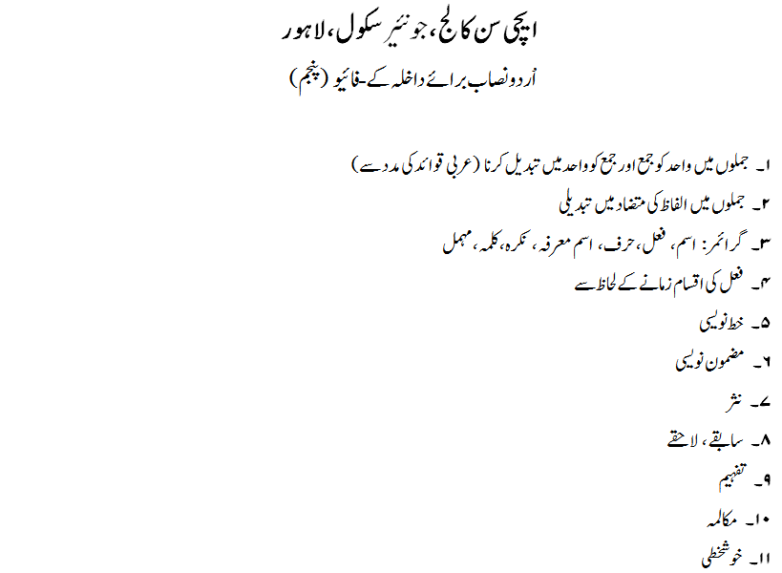

**JUNIOR SCHOOL** *(continued)*

FOR ADMISSION TO CLASS: Grade 6 or K-6 **(Guide only)**

**ENGLISH Time: 1 Hour 10 Min.**

**Note:** Questions will be based on some or all of the following areas in 1 & 2:

Analyse or make inferences from an unseen passage.

1. Comprehension

Approximately 300 word imaginative piece. . A candidate’s language/written skills will be gauged from an ability to form responses or convey ideas with coherency, imagination, powers of description, use of vocabulary or choice of words, accuracy of spelling, simple sentence construction, imagination, description, and application of basic grammar rules.

1. Short Essay

**JUNIOR SCHOOL** *(continued)*

FOR ADMISSION TO CLASS: Grade 6 or K-6 **(Guide only)**

**MATHEMATICS**

**Time: 1 Hour 30 min.**

**Note:** Use of calculator is allowed.

Questions will be based on some or all of the following topics:

**SETS**

* Concepts of a set and its members
* Notation (two forms)
* Finite and infinite sets
* Singleton and empty sets
* Cardinality of a set
* Subsets
* Place value of numbers up to 7 digits
* Ordering, comparing, rounding numbers

**WHOLE NUMBER SYSTEM**

* Concept of directed numbers. To show numbers on rays and lines. Opposite integers. Addition of integers on a line
* Multiplication: one of the numbers is a 3 digit number and the other is a 5-digit number
* Division: One of the numbers is a 3 digit and the other is a 6 digit number
* Emphasis on Word Problems which will be selected from various sources
* Multiples and Factors, Odd and Even numbers, Prime numbers, Sequences,

Divisibility Rules

**RATIONAL NUMBERS (COMMON AND DECIMAL FRACTIONS)**

* Conversion of Common Fractions to Decimal Fractions and vice versa up to 3 decimal places
* Addition, Subtraction, Multiplication and division of Decimal Fractions and Common Fractions.
* Rounding off Decimal Fractions (up to three decimal places)
* Use of brackets involving Whole Numbers and Decimal Fractions (two brackets in a problem)
* Word Problems
* Simplification of Common Fractions, Equivalent Fractions
* Simplifying expressions involving three brackets (emphasis on problems involving Whole Numbers and Decimal Fractions)

**PERCENTAGE**

* Percentage of whole numbers
* Conversion of % into Common Fractions and vice versa
* Conversion of % into Decimal Fractions and vice versa
* Common Fraction Form, Decimal Fraction Form and Percent Form of a Rational Number and their inter-links (simple cases)
* Direct and simple word problems

**SHAPES AND MEASURES**

* Polygons, 2D and 3D shapes, Prisms, Pyramids, Polyhedra, Nets of 3D shapes.
* Types of quadrilaterals:

(i) Scalene (ii) Trapezium (iii) Parallelogram

(iv) Rhombus (v) Rectangle (vi) Square (vii) European Kite

* Working with Length.
* Transformation: Translation, Reflection, Rotation.
* Measurement of straight lines

**UNKNOWN ANGLES**

* Sum of measure of the angles on a straight line and at a point
* Construction and measurement of angles with the help of a protractor
* Sum of measures of interior angles of a triangle
* Sum of measures of interior angles of a quadrilateral
* Finding measure of an unknown interior angle of a quadrilateral

**AREA AND PERIMETER**

* S.I. units of area and their conversions
* Area of square, rectangle and irregular shapes (using square grid).
* Finding perimeters of quadrilateral regions, regular and irregular polygons.
* Word problems on area and perimeter
* Mass and capacity
* Volume of cubes and cuboids

**TIME**

* Understanding the use 24 hour and 12 hour clocks
* Word problems involving days, hours, minutes and seconds
* Timetables, Calendars.

**DATA HANDLING:**

* Line Graph, Pie Chart, Bar Graph
* Average: (Mean, Median, Mode)
* Probability
* Venn diagram
* Ratio and Proportion

**JUNIOR SCHOOL** *(continued)*

FOR ADMISSION TO CLASS: Grade 6 or K-6 **(Guide only)**

**URDU Time: 1 Hour 10 min.**

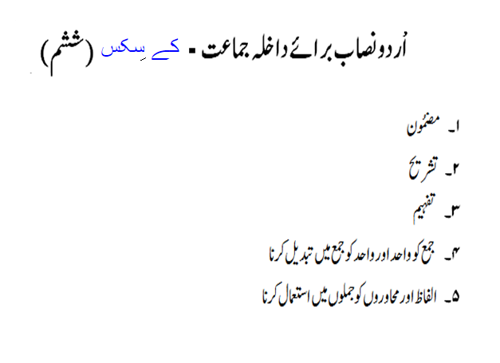

**PREPARATORY SCHOOL**

FOR ADMISSION TO CLASS: Grade 7 or E-2 **(Guide only)**

**ENGLISH Time: 1 Hour 15 min.**

1. Essay Writing/Short Story Imaginative Piece (Max 400 Words)
2. Comprehension (unseen passage)

**MATHEMATICS Time: 1 Hour 30 min.**

**Note:** Use of calculator is allowed.

Questions will be based on some or all of the following topics:

**SETS**

* Concepts of a set and its members
* Definition of a set and its types
* Definition of cardinality, finite and infinite sets
* Definition of a singleton, empty and subset
* *Union* and *Intersection* of sets

**REAL NUMBER SYSTEM (INTEGERS)**

* Sets of natural numbers, whole numbers and integers
* Even, odd, prime and composite integers

**FACTORS AND MULTIPLES**

* G.C.D. and L.C.M. of three numbers by prime factorisation method
* G.C.D. of two and three numbers by division method
* Link between G.C.D. and L.C.M.
* Word Problems

**BODMAS/THE FOUR OPERATIONS**

* Simplifying expressions involving two brackets
* Simplifying expressions involving three brackets (emphasis on problems involving common fractions)

**BASICS OF ALGEBRA**

* Introduction to *Algebraic Expression*
* Concept of *Coefficient*, variable and constant
* Concept of *Exponent* and *Base*
* Writing a natural number in exponential form
* Arranging a polynomial in ascending and descending order. First and second degree polynomials in one variable (Monomial, Binomial and Trinomial)
* Addition and Subtraction of monomials, binomials, and trinomials of first and second degree
* Multiplying and dividing one and two degree polynomials by a monomial

**ALGEBRAIC SENTENCES**

* Definition of expression, algebraic sentence, open sentences, equations and inequations

**SOLUTION OF LINEAR EQUATION**

* Solution of linear equations in one variable

**SQUARE AND SQUARE ROOTS**

* Finding squares of integers
* Finding square roots of perfect square numbers by prime factorisation method or by division method

**PERCENTAGES**

* Expressing a given quantity as a percentage of the other
* Percentage increase or decrease in a given quantity
* Word problem about percentage increase or percentage decrease

**POLYGONS**

* Introduction of plane, flat and curved surfaces
* Definition of a polygon, vertex, side and diagonal of a polygon
* Types of polygons (triangle, quadrilateral, pentagon, hexagon, heptagon, octagon) Introduction of regular and irregular polygons
* Definition of reflex angle
* Definitions of concave and convex polygons
* Drawing of convex polygons (pentagon, hexagon and octagon)
* Number of diagonals in 4-sided to 8-sided polygons
* Identification of exterior and interior angles of a polygon
* Find the measure of interior angles of a regular polygon and the sum of measures of all interior angles of a regular 3-sided to 8-sided polygon

**AREA AND PERIMETER**

* Finding perimeter of a semi-circular and quarter-circular region
* Finding area and perimeter of a triangular region
* Finding area and perimeter of shapes consisting of a combination of circular, semi-circular, triangular and square regions

**LINES AND ANGLES**

* Definition of parallel lines, rays and segments
* Identification of adjacent, alternate, corresponding, interior, vertically opposite, complementary and supplementary angles
* Finding measure of unknown angles at a point and on a straight line. Finding measure of unknown angles of a triangle

**GEOMETRICAL CONSTRUCTION**

* Construction of angles of measure 75o,105o,120o,135o and 150o with a pair of compasses
* Construction of triangle (all types)

**INFORMATION HANDLING**

* Introduction of different types of graphs (pie chart, bar graph, etc.)
* Interpretation of bar graph and pie chart
* Interpretation of pie chart and construction of bar graph

**PREPARATORY SCHOOL** *(continued)*

FOR ADMISSION TO CLASS: Grade 7 or E-2 **(Guide only)**

**URDU**

**Time: 1 Hour 10 min.**

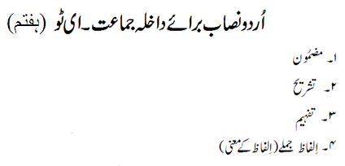

**PREPARATORY SCHOOL** *(continued)*

FOR ADMISSION TO CLASS: Grade 8 or M-1 **(Guide only)**

**ENGLISH Time: 1 Hour 15 min.**

1. Essay Writing/Short Story (Max. 400 Words)
2. Comprehension (unseen Passage)

**MATHEMATICS Time: 1 Hour 30 min.**

**Note:** Use of calculator is allowed.

Questions will be based on some or all of the following topics:

**REAL NUMBER SYSTEM (RELATIONAL NUMBERS)**

* Multiplication and division of integers
* Introduction of rational and the set of rational numbers
* Addition and subtraction of rational numbers
* Multiplication and division of rational numbers. (emphasis on problems involving negative common and decimal fractions)

**BODMAS**

* Simplifying expressions involving three brackets (problems involving negative, common and decimal fractions)

**CUBE ROOT AND SQUARE ROOT**

* Finding cube root of perfect cube numbers by prime factorisation method
* Finding square root of a rational number by prime factorisation method and by division method

**ALGEBRAIC EXPRESSIONS**

* Introduction of expressions of third and fourth degree in one variable
* Introduction of expressions of first and second degree in two variables
* Addition and subtraction of polynomials in one and two variables of first and second degrees (involving one pair of brackets)
* Multiplication of linear and quadratic polynomials in one variable (Division of up to trinomials)
* Simplification of linear and quadratic polynomials in one variable involving one or two brackets
* Evaluation of monomials and binomials in one variable up to second degree
* Evaluation of monomials and binomials in two variables up to second degree
* Evaluation of polynomials in one variable up to third degree

**FACTORISATION OF ALGEBRAIC EXPRESSIONS**

* Factorisation of algebraic expressions (involving common factors only)

**SOLUTION OF LINEAR EQUATIONS**

* Solution of linear equations in one variable
* Word problems

**RATIO AND PROPORTION**

* Introduction of Ratio and Equivalent Ratio
* Increase and Decrease in Ratios.
* Rate and Proportional Parts

**DIRECT AND INVERSE PROPORTION**

* Word Problems

**PERCENTAGE**

* Percentage Change, Percentage Profit, Percentage Loss

**FINDING SELLING PRICE AND COST PRICE**

* Word problems

**SIMPLE INTEREST**

* Finding Simple Interest, Amount, Rate and Time, using I = $\frac{PRT}{100}$ and finding *Principal* when amount is given.

**MENSURATION**

* Area and perimeter of shaded regions consisting of circular, semi-circular, triangular, rectangular and square regions
* Finding volume of a solid cylinder, cube and cuboid
* Finding surface area of a cube, cuboid and closed cylinder

**ANGLES**

* Finding unknown angles on a line and at a point
* Finding unknown angles produced by parallel lines and a transversal (corresponding angles, alternate angles, interior angles)
* Finding unknown angles of triangles and quadrilaterals

**SIMULTANEOUS LINEAR EQUATIONS**

* Solution of simultaneous linear equation involving two variables

**GEOMETRICAL CONSTRUCTION**

* Construction of triangles (SSS, SAS, SAA and right angled triangle)
* Construction of quadrilaterals (square, rhombus, rectangle and parallelogram)

**INTERIOR & EXTERIOR ANGLES OF A POLYGON**

* Finding an interior angle of a regular polygon
* Use of formula for finding the sum of the measure of interior and exterior angles of a polygon
* Finding sum of the measure of interior angles of a pentagon, hexagon, heptagon and octagon

**PREPARATORY SCHOOL** *(continued)*

FOR ADMISSION TO CLASS: Grade 8 or M-1 **(Guide only)**

**URDU**

**Time: 1 Hour 10 min.**

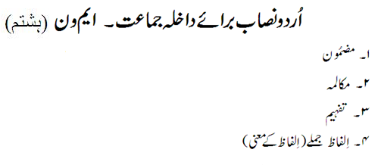**PREPARATORY SCHOOL** *(continued)*

FOR ADMISSION TO CLASS: Grade 9 or M-2 **(Guide only)**

**ENGLISH Time: 1 Hour 30 min.**

1. Essay Writing/Short Story Imaginative Piece (Max 500 Words)
2. Comprehension (unseen passage)

**MATHEMATICS Time: 1 Hour 30 min.**

**Note:** Use of calculator is allowed.

Questions will be based on some or all of the following topics:

1. Real Numbers their square roots and cube roots
2. Estimation
3. Algebraic Manipulation
4. Algebraic Manipulation and Factorisation
5. Solution of Linear Equations and Word Problems
6. Measures
7. Ratio and Proportion
8. Percentage
9. Mensuration
10. Angles
11. Geometrical Construction

**SENIOR SCHOOL**

FOR ADMISSION TO CLASS: Grade 10 or C-1 **(Guide only)**

**ENGLISH Time: 1 Hour 30 min.**

Essay Writing (one out of five given topics, approx. 500 – 600 words)

Comprehension (unseen passage)

**MATHEMATICS Time: 1 Hour 30 min.**

**Note:** Use of calculator is allowed.

Questions will be based on some or all of the following topics:

1. Profit and Loss, Percentages, Simple interest
2. Indices, Laws of Indices
3. Simultaneous Linear Equations (including Word Problems)
4. Algebraic Expressions and Quadratic Equations (including Word Problems)
5. Symmetry (Line Symmetry, Rotational Symmetry) and Angle Properties of Polygons
6. Congruency and Similarity
7. Mensuration (Sectors, Prisms, Cone, Pyramid, Spheres, Cylinders, Finding Area and Volumes)
8. Graphs (Linear Graphs, Travel Graphs, Graphs of a Quadratic Equation in two variables)
9. Algebraic Fractions
10. Variations (Direct, Inverse and Joint Variation)
11. Pythagoras' theorem (Figures and Word Problems)
12. Quadratic Equations including Word Problems
13. Statistics (Mean, Median, Mode)
14. Trigonometric Ratios (Value of Trigonometric Ratios, Finding the value of an angle with Trigonometric Ratios, Practical Applications of Trigonometry)

**SENIOR SCHOOL** *(continued)*

FOR ADMISSION TO CLASS: Grade 11 or C-2 **(Guide only)**

**ENGLISH Time: 1 Hour 30 min.**

Essay Writing (one out of five given topics, approx. 500 – 600 words) Comprehension (unseen passage)

**MATHEMATICS Time: 1 Hour 30 min.**

**Note:** Use of calculator is allowed.

Questions will be based on some or all of the following topics:

Topics include:

* Algebra
* Factorization
* Solving Quadratic equations by completing square
* Solving Quadratic equations by quadratic formulae
* Coordinate Geometry
* Graphs of quadratic curves & gradient of curve at the point
* Angle properties of circle
* Trigonometry
* Bearings
* The Sine Rule
* The Cosine Rule
* Area of a triangle
* Problems in Three Dimensions
* Mensuration
* Matrices
* Loci
* Statistics
* Frequency Tables
* Statistical Diagrams
* Cumulative Frequency Curve (medians, quartiles & percentiles)
* Grouped frequency distribution & Modal class